**Practice Set-1**

**Ques-1.** Write a program for the addition of Two Numbers.

**Code:**

num1 = int(input("Enter 1st number"))  
num2 = int(input("Enter 2nd number"))  
sum = num1 + num2

print("Addition = "**,** sum)

**Output:**

Enter 1st number: 55

Enter 2nd number: 58

Addition = 113

**Snapshot:**

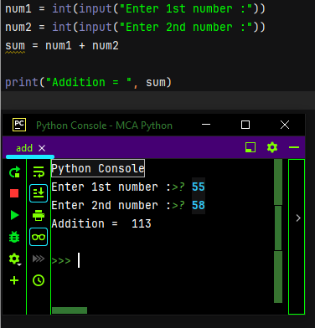

**Ques-2.** Write a program to read two numbers and print their quotient and remainder.

**Code:**

num1 = int(input("Enter 1st number"))  
num2 = int(input("Enter 2nd number"))  
ques = (num1 // num2)  
rem = (num1 % num2)  
print("quotient = "**,** ques)  
print("remainder = "**,** rem)

**Output:**

Enter 1st number>? 3215

Enter 2nd number>? 26

quotient = 123

remainder = 17

**Snapshot:**

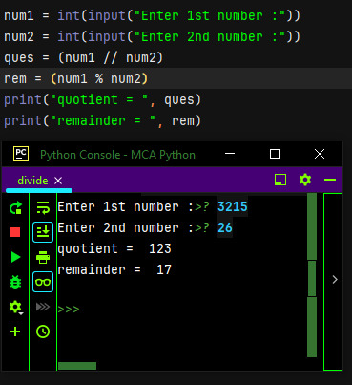

**Ques-3.** Write a program to find the Average of Three Numbers.

**Code:**

num1 = int(input("Enter 1st number"))  
num2 = int(input("Enter 2nd number"))  
num3 = int(input("Enter 3rd number"))  
avg = (num1 + num2 + num3)/**3**print(avg)

**Output:**

Enter 1st number>? 55

Enter 2nd number>? 69

Enter 3rd number>? 98

Average = 74.0

**Snapshot:**

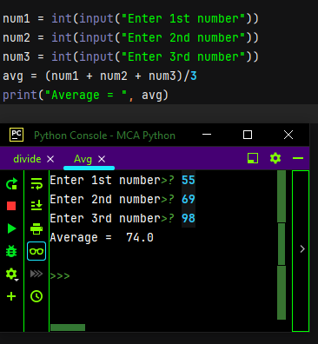

**Ques-4.** Write a program to Calculate Sum of 5 Subjects and Find Percentage (Max Mark in each subject is 100).

**Code:**

S1 = int(input("Enter S1 marks"))  
S2 = int(input("Enter S2 marks"))  
S3 = int(input("Enter S3 marks"))  
S4 = int(input("Enter S4 marks"))  
S5 = int(input("Enter S5 marks"))  
Total = S1+S2+S3+S4+S5  
percent = (Total/**500**)\***100**print('Total marks is {0} and percent {1}'.format(Total**,** percent))

**Output:**

Enter S1 marks>? 55

Enter S2 marks>? 70

Enter S3 marks>? 82

Enter S4 marks>? 96

Enter S5 marks>? 85

Total marks is 388 and percent 77.60000000000001

**Snapshot:**

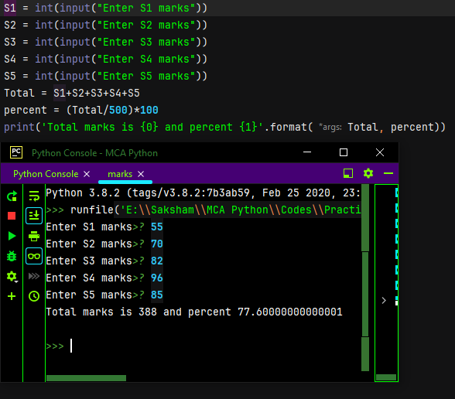

**Ques-5** Write a program to find gross salary.

**Code:**

bs = float(input("Enter the Basic Salary :"))  
if bs < **15000**:  
 hra = bs * **0.1** da = bs * **0.9** print("HRA = "**,** hra)  
 print("DA = "**,** da)  
else:  
 hra = **5000** da = bs * **0.98** print("HRA = "**,** hra)  
 print("DA = "**,** da)  
  
gs = bs + hra + da  
print("Gross Salary Rs :"**,** gs)

**Output:**

Enter the Basic Salary :>? 25000

HRA = 5000

DA = 24500.0

Gross Salary Rs: 54500.0

**Snapshot:**

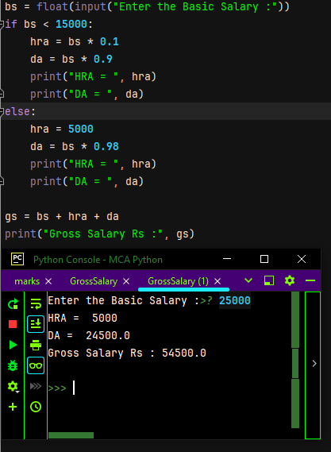

**Ques-6** Write a program to Calculate Area of Circle.

**Code:**

PI = **3.14**R = float(input("Enter radius of a circle :"))  
area = PI*R*R  
print("Area of circle = "**,** area)

**Output:**

Enter radius of a circle :>? 5

Area of circle = 78.5

**Snapshot:**

